**Sprint 2 Plan**

**Meme Feed**

**Meme Teme**

**1/29/19**

**Revision 0**

**Goal:**

For this sprint, our goal is to resolve issues from the sprint prior and set up the storage and display of user info.

**Task Listing:**

(1) As a User, I want to be able to create and log into an account with my information **(21)**

* Have an Account Login Page to re login or sign up **(1)** *(Emma)*
* Allow the user to only have to sign in one time **(3)** *(Siddhi)*
* Ability to log out. **(2)** *(Siddhi)*
* Create an account utilizing, require user to enter (email, full name, user name, passwords) **(9)** *(Jon)*
* Allow the user to have email verification, to secure user profiles. **(5)** *(Jon)*

(2) As a developer, I want to be able to scrape the web to find memes. **(7)**

* Put web scraper memes into firebase & include time, category, source, upvote count at time pulled, user who posted **(7)** *(Zac)*
* Set up firebase to Mia’s debit card USE gift card

(3) As a user, I want a General Feed page to see all of the memes in chronological order. **(7)**

* Pull memes from firebase every 12 hours and put them onto the general feed tab **(5) *(****Mia)*
* Sort memes in the order that they were posted. **(2)** *(Siddhi)*

(4) As a user, I want the General Feed page to have two different views so that I can view at a different pace **(11)**

* Buttons for full feed & scroll which change the view **(3)** *(Siddhi)*
* Ability to tap on a meme in grid view and have it go to a full view of just that singular meme **(3)** *(Emma)*
* Have the ability to scroll through a single feed to see more memes **(5)** *(Emma)*

(5) As a developer, I want the app to work so I can continue implementing tasks **(20)**

* Fix the podfile bugs linking with react native **(20)** *(EVERYONE)*

(6) As a user I want to be able to like and dislike memes on scale of emojis **(23)**

* Store user likes in firebase, update current reaction or add new reaction when user reacts to a post. Be aware to grab the time of their initial reaction **(10)** *(Jon)*
* When clicking an image that image will show if the user previously reacted and the rating **(7)** *(Zac)*
* Display the five emojis for a user to react with **(6)** *(Mia)*

(7) As a User, I want my own account page where people can see the memes I like (personal user page) **(20)**

* Create a page for personal memes **(1)** *(Emma)*
* Repurpose grid view for this page **(2)** *(Mia)*
* Logout button **(1)** *(Siddhi)*
* Repurpose list view for memes **(2)** *(Siddhi)*
* Pull users liked memes from firebase (3&4 rated memes) **(5)** *(Zac)*
* Sort liked memes from firebase chronologically by react time **(3)** *(Jon)*
* Add memes to user page, take the memes already pulled from firebase and visualize them on the page **(5)** *(Emma)*
* Tab navigator **(1)** *(Zac)*

**Team Roles:**

**Mia:** Product Owner, Developer

**Emma:**  Developer

**Siddhi:**  Developer

**Zach:**  Developer

**Jon:** Scrum Master, Developer

**Initial Task Assignment:**

**Mia:**

(3) As a user, I want a General Feed page to see all of the memes in chronological order. **(7)**

* Pull memes from firebase every 12 hours and put them onto the general feed tab **(5) *(****Mia)*

(5) As a developer, I want the app to work so I can continue implementing tasks **(20)**

* + Fix the podfile bugs linking with react native **(4)** *(EVERYONE)*

(6) As a user I want to be able to like and dislike memes on scale of emojis **(23)**

* + Display the five emojis for a user to react with **(6)** *(Mia)*

(7) As a User, I want to my own account page where people can see the memes I like (personal user page) **(20)**

* Repurpose grid view for this page **(2)** *(Mia)*

**Emma:**

(1) As a User, I want to be able to create and log into an account with my information **(21)**

* Have an Account Login Page to re login or sign up **(1)** *(Emma)*

(4) As a user, I want the General Feed page to have two different views so that I can view at a different pace **(11)**

* Ability to tap on a meme in grid view and have it go to a full view of just that singular meme **(3)** *(Emma)*
* Have the ability to scroll through a single feed to see more memes **(5)** *(Emma)*

(5) As a developer, I want the app to work so I can continue implementing tasks **(20)**

* + Fix the podfile bugs linking with react native **(20)** *(EVERYONE)*

(7) As a User, I want to my own account page where people can see the memes I like (personal user page) **(20)**

* Create a page for personal memes **(1)** *(Emma)*
* Add memes to user page, take the memes already pulled from firebase and visualize them on the page **(5)** *(Emma)*

**Siddhi:**

(1) As a User, I want to be able to create and log into an account with my information **(21)**

* Allow the user to only have to sign in one time **(3)** *(Siddhi)*
* Ability to log out. **(2)** *(Siddhi)*

(3) As a user, I want a General Feed page to see all of the memes in chronological order. **(7)**

* Sort memes in the order that they were posted. **(2)** *(Siddhi)*

(4) As a user, I want the General Feed page to have two different views so that I can view at a different pace **(11)**

* Buttons for full feed & scroll which change the view **(3)** *(Siddhi)*

(5) As a developer, I want the app to work so I can continue implementing tasks **(20)**

* + Fix the podfile bugs linking with react native **(20)** *(EVERYONE)*

(7) As a User, I want to my own account page where people can see the memes I like (personal user page) **(20)**

* Logout button **(1)** *(Siddhi)*
* Repurpose list view for memes **(2)** *(Siddhi)*

**Zac:**

(2) As a developer, I want to be able to scrape the web to find memes. **(7)**

* Put web scraper memes into firebase & include time, category, source, upvote count at time pulled, user who posted **(7)** *(Zac)*
* Set up firebase to Mia’s debit card USE gift card

(5) As a developer, I want the app to work so I can continue implementing tasks **(20)**

* + Fix the podfile bugs linking with react native **(20)** *(EVERYONE)*

(6) As a user I want to be able to like and dislike memes on scale of emojis **(23)**

* When clicking an image that image will show if the user previously reacted and the rating **(7)** *(Zac)*

(7) As a User, I want to my own account page where people can see the memes I like (personal user page) **(20)**

* Pull users liked memes from firebase (3&4 rated memes) **(5)** *(Zac)*
* Tab navigator **(1)** *(Zac)*

**Jon:**

(1) As a User, I want to be able to create and log into an account with my information **(21)**

* Create an account utilizing, require user to enter (email, full name, user name, passwords) **(9)** *(Jon)*
* Allow the user to have email verification, to secure user profiles. **(5)** *(Jon)*

(5) As a developer, I want the app to work so I can continue implementing tasks **(20)**

* + Fix the podfile bugs linking with react native **(20)** *(EVERYONE)*

(6) As a user I want to be able to like and dislike memes on scale of emojis **(23)**

* + Store user likes in firebase, update current reaction or add new reaction when user reacts to a post. Be aware to grab the time of their initial reaction **(10)** *(Jon)*

(7) As a User, I want to my own account page where people can see the memes I like (personal user page) **(20)**

* Sort liked memes from firebase chronologically by react time **(3)** *(Jon)*

**Initial Burn Up Chart:**

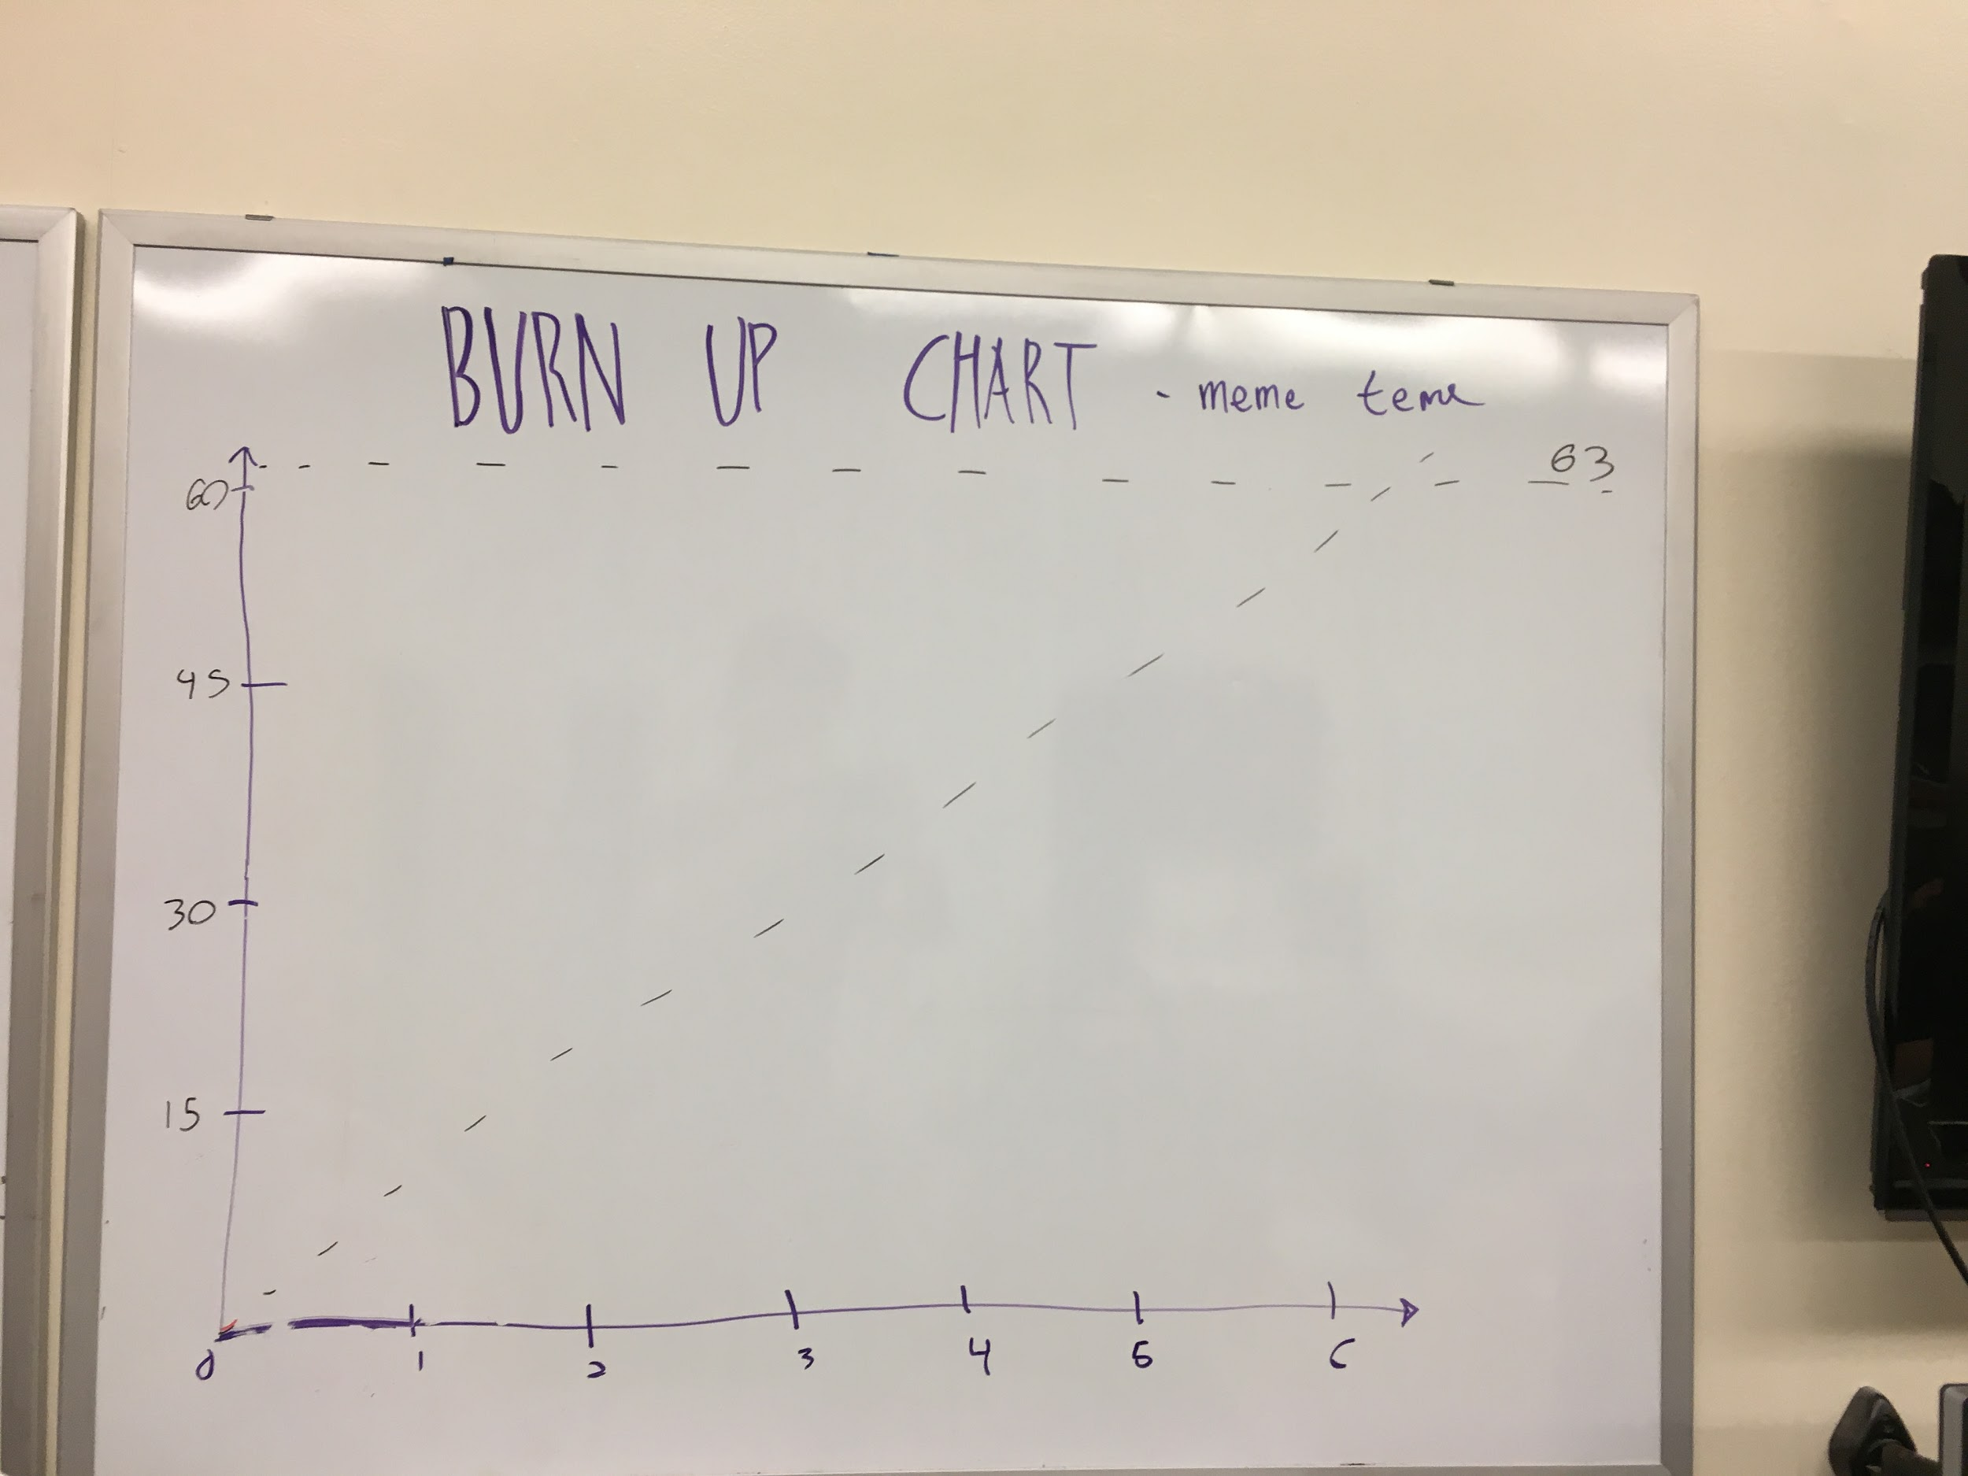

**Initial Scrum Board:**

